Assignment 4 :

1.Open your own laptop or desktop (or use an online PC hardware simulator if you don't have access to a real system) and identify the GPU model installed. Write down the GPU's brand, model number, and whether it is integrated or dedicated.

GPU 1
- Brand: AMD
- Model Number: Radeon HD 8500M
- Type: Dedicated (Discrete) Graphics Card
GPU 2
- Brand: Intel
- Model Number: Intel(R) HD Graphics Family
- Type: Integrated Graphics (Built into the CPU)
Your laptop uses switchable graphics (dual GPU):
- Intel HD Graphics is used for normal tasks to save battery.
- AMD Radeon HD 8500M is used for graphics-intensive tasks like gaming, video editing, and 3D applications.

2.Take a clear photo or screenshot of the cooling system (fan, heatsink, or liquid cooling setup) inside your PC or from a PC hardware simulator. Label the main cooling components and briefly describe their function.

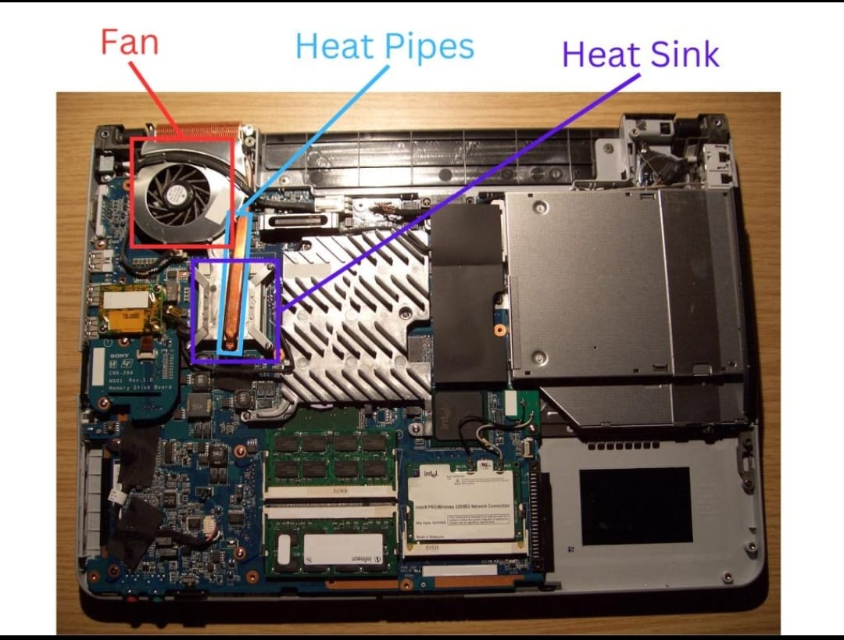
• Cooling Fan
- Draws cool air into the laptop.
- Blows hot air away from the heatsink to reduce temperature.
• Heatsink
- A metal component with thin fins.
- Absorbs heat from the CPU and GPU and transfers it to the airflow from the fan.
• Heat Pipe
- A copper tube connecting the CPU/GPU to the heatsink.
- Carries heat quickly from the processor to the heatsink.

3.Create a comparison table listing at least 3 differences between air cooling and liquid cooling systems for GPUs, including factors like cost, efficiency, and maintenance.
Factor | Air Cooling | Liquid Cooling
Cost | Cheaper | More expensive
Cooling | Good for normal use and gaming | Better for heavy gaming and high-performance work
Maintenance | Easy – just clean the dust from the fan | Needs more care – check the liquid, pump, and tubes
Noise | It makes noise | silent
Installation | Easy to install | More difficult to install

4.Imagine you are building a gaming PC for streaming IPL matches and playing graphics-heavy games. Choose between air cooling and liquid cooling for your GPU, and justify your choice in 3-4 sentences based on your research.

Answer---

I would choose liquid cooling for my GPU. It keeps the GPU cooler during long gaming and streaming sessions, which helps maintain better performance. It also produces less noise than high-speed air cooling fans. Although liquid cooling costs more and needs more maintenance, it is the better choice for a high-end gaming and streaming PC.

